EXPRO National Manual of Assets and Facilities Management

Volume 12, Chapter 2

Operations and Maintenance (O&M) Risk Management Plan Template

Document No.: EOM-EM0-TP-000001 Rev 001

Document Submittal History:

Revision: | Date: | Reason For Issue
000 | 28/03/2020 | For Use
001 | 18/08/2021 | For Use

THIS NOTICE MUST ACCOMPANY EVERY COPY OF THIS DOCUMENT
IMPORTANT NOTICE

This document, (“Document”) is the exclusive property of Government Expenditure & Projects Efficiency Authority.
This Document should be read in its entirety including the terms of this Important Notice. The government entities may disclose this Document or extracts of this Document to their respective consultants and/or contractors, provided that such disclosure includes this Important Notice.
Any use or reliance on this Document, or extracts thereof, by any party, including government entities and their respective consultants and/or contractors, is at that third party’s sole risk and responsibility. Government Expenditure and Projects Efficiency Authority, to the maximum extent permitted by law, disclaim all liability (including for losses or damages of whatsoever nature claimed on whatsoever basis including negligence or otherwise) to any third party howsoever arising with respect to or in connection with the use of this Document including any liability caused by negligent acts or omissions.
This Document and its contents are valid only for the conditions reported in it and as of the date of this Document.

Table of Contents

1.0 Purpose and scope 5
2.0 Terms and definitions 5
3.0 Key O&M management interfaces 5
4.0 References 6
5.0 Roles and responsibilities 6
5.1 Facility Manager 6
5.2 Risk Manager 6
5.3 O&M Team 6
5.4 Risk Owner 7
5.5 Risk Treatment Owners 7
6.0 Process 7
6.1 Overview of the Process 7
6.2 Governance Arrangements 8
6.3 [Other Governance Arrangements] 9
7.0 O&M risk assessment methodology 10
7.1 O&M Risk Impact and Likelihood Categories 10
7.2 Risk Likelihood Categories 12
7.3 O&M Risk Tolerance Criteria 12
8.0 Attachments 13
Attachment 1 - EOM-EM0-TP-000002 – O&M Risk Register Template 14

Purpose and scope
[Note – this document is a template for the Operations and Maintenance (O&M) risk management plan. It should be edited by the Facility Manager (FM) for the purposes of applying it to an individual facility. The convention adopted is that all text inside square brackets and in bold italics, provides guidance on the O&M risk management plan requirements to the FMs. It should be deleted and / or edited by the FM to reflect the specific O&M risk management arrangements that will be employed for the specific project. The O&M risk management plan will be a stand-alone document for each facility.]
Expro requires each Facility Manager (FM) to develop a Operation and Maintenance (O&M) Management plan for every facility that the FM is responsible for operating and maintaining.
The purpose of the risk management plan is to:
- specify clear roles and responsibilities for managing O&M risk
- define the O&M risk management process that will be employed by the FM for managing O&M risk
- define the O&M risk management reporting, escalation and governance arrangements that will be employed on the facility
- specify the key O&M management interfaces with other processes and procedures
- define the O&M risk assessment methodology and the associated risk tolerance criteria that will be employed on the facility.

The scope of the O&M risk management plan will be informed by the O&M Delivery Strategy (EPM-S00-GL-000002) - which will define the O&M delivery strategy (e.g. the strategic, tactical and operational levels of O&M). The O&M risk management plan will apply to all stages in the facility/asset life cycle.

[Note – the O&M risk management procedure describes how risks will be considered during the facility/asset life cycle.]

The O&M risk management plan will clearly identify any critical O&M interfaces, and how these will be managed. For example, the management of the range of assets from simple assets that require little / simple O&M to more complex hazardous assets.

This O&M risk management plan will apply to THE FACILITY:
[Facility title and Ministry cross reference numbers to be provided here.]
……………………………………………………………………………………………………………

It applies to O&M management services that will be delivered to THE CUSTOMER:
[Ministry name to be provided here.]
……………………………………………………………………………………………………………

By the following THE SUPPLIER:
[FM designated name or consultancy organization’s name to be provided here.]
……………………………………………………………………………………………………………

Terms and definitions
The O&M risk management procedure contains an extensive and comprehensive glossary of commonly used O&M risk management terms and definitions. These are not repeated here.

Key O&M management interfaces
The O&M risk management activities that will be undertaken to comply with the O&M risk management procedure, and in accordance with this O&M risk management plan, will be informed by the O&M Execution Plan.
The O&M risk management activities apply to all stages of the facility / asset life cycle.

References
Key references cited in this plan are as follows:

- EOM-EM0-PR-000001 – Operation and Maintenance (O&M) Risk Management Procedure.
- EOM-EM0-TP-000002 – Operation and Maintenance (O&M) Risk Register Template.
- EOM-EM0-GL-000001 – Operation and Maintenance (O&M) Risk Management Introduction Guideline.
- EPM-S00-GL-000002 – Operation and Maintenance (O&M) Delivery Strategy.

Roles and responsibilities
In this section the key roles associated with managing and executing the risk management plan will be identified and the responsibilities of each key role described.

A named individual MUST be provided for the Facility Manager role before the O&M risk management plan can be issued.

As the O&M risk management plan is developed, then other roles may have names allocated to them but this will be at the direction of the Facility Manager. Over the whole facility / assets life cycle then named individuals against specific roles will change. A register of these named individuals shall be maintained at the direction of the Facility Manager which will capture the historical record of all changes in key roles.

[The following list of key roles will be required as a minimum.
The O&M risk management procedure provides a template description of the specific responsibilities that each of these key roles will be expected to fulfill. Brief summaries of these specific responsibilities are provided here but the procedure should be referred to for the fuller descriptions.]

Facility Manager
- To provide overall direction for the facility, including O&M risk management activities
- To support all internal and external interface and resource requirements.

Risk Manager
- To support the Facility Manager by managing the O&M risk management process
- To engage with all internal and external stakeholders and facilitate all communication requirements
- To manage the interfaces with all other relevant O&M management processes
- To maintain the O&M risk register and facilitate all data collation in support of this.

O&M Team
- To participate in and contribute to the execution of the O&M risk management process throughout the complete facility / asset life cycle.

[Note –membership of the Facility team will vary according to the specific O&M life cycle stage. The Risk Manager will recommend facility team membership, but membership will be determined by the Facility Manager.]
- To provide expert input on the allocation of Risk Owners for all identified O&M risks
- To provide guidance and expert input on any decisions about risk management intervention options.

Risk Owner
- These are nominated by the project team against individual risks, and approved by the Facility Manager
- Responsible for the management of any risks allocated to them – and are answerable to the Facility Manager
- Provide suggestions to the facility team on the risk management interventions that could be employed to help manage specific risks.

Risk Treatment Owners
- These are nominated by the Risk Owner
- Responsible for the implementation and execution of agreed risk management interventions - and are answerable to the Risk Owner
- Responsible for monitoring and reporting effectiveness of the risk management interventions that they are responsible for.

Process
The O&M risk management process that will be followed is fully described in the O&M risk management procedure (EOM-EM0-PR-000001). A schematic representation of this process is reproduced in the following overview for information and cross reference.

All O&M risks will be recorded in the O&M risk register in accordance with the requirements described in the O&M risk management procedure. A template risk register has been developed for this purpose (O&M risk register template: EOM-EM0-TP-000002), and an example of this is presented in Attachment 1.

Overview of the Process

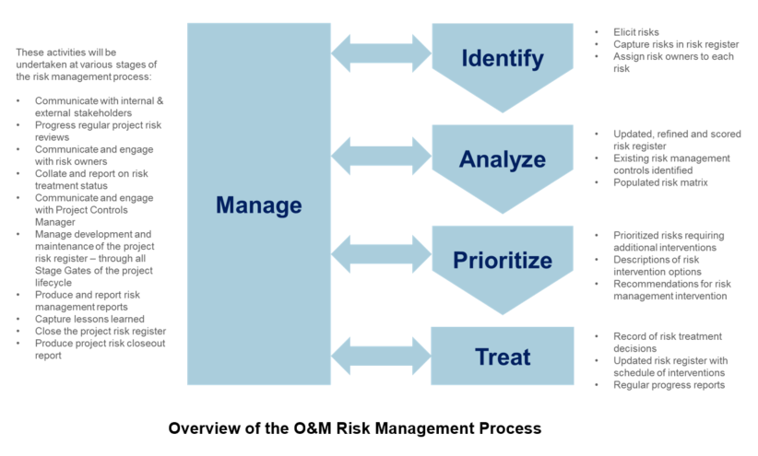

The steps in the O&M risk management process are:

- Identify risks via risk elicitation, draft their risk statements, and assign Risk Owners. All risks will be captured in a O&M risk register.
- Analyze risks through an examination and documentation of causes and effects, categorize the risks by their sources, and determine potential impact dates.
- Prioritize risks based on estimation of likelihood and impacts, determine the current risk ranking on the risk matrix, and recommend risk management intervention options based on its risk priority.
- Treat risks where the risk management interventions are judged to be practicable and result in tolerable residual risk, regularly evaluate the effectiveness of these risk treatments.
- Manage risks by undertaking regular monitoring and review activities, ensuring O&M risk register data quality, ensuring alignment with functional interfaces, executing risk response plans, providing reports and metrics, taking advantage of opportunities, closing risks, and completing lessons learned.

These process steps will be performed in accordance with the O&M risk management procedure.

Governance Arrangements
The O&M risk management activities that are managed and overseen by the Risk Manager will be undertaken according to a predetermined management cycle that will be agreed and approved by the Facility Manager.
These are recorded here:

[The following table provides an example of this cycle but the actual timings will be specified for each Facility.]
Prior to: | Activity [edit table as appropriate]
1st of the Month | - Risk owners review their risks for update and action using reports and metrics provided by the Risk Manager
2nd to 22nd of each Month | - Risk manager, Risk Owners and other risk stakeholders update risks in the O&M risk register, and evaluate risk response plans as required by risk review requirements  - From stakeholder discussions, consideration is given to the potential for new risks for consideration by the O&M management team at the monthly risk meeting, or sooner if a high-level risk is foreseen
23rd of each Month | - The risk register is frozen at month-end for report development and for a copy to be archived
25th of each Month | - The Risk Manager issues reports and metrics to the Facility Manager, O&M team (or O&M risk review group), Risk Owners, and other stakeholders (e.g. the customer)  - Risk manager ensures data archival requirements are complied with
28th of each Month | - The monthly project risk review meeting is held with the O&M team (or O&M risk review group)
Quarterly | - O&M team (or O&M risk review group) undertake a full review of the O&M risk register  - Review of overall effectiveness of O&M risk management plan and associated activities with the O&M management team
Semi-Annually | - O&M risk identification workshop with the O&M team (or O&M risk review group) and other risk stakeholders  - Health check of O&M risk management process, either as part of Stage Gate Process, by the project team (or project risk review group), or independently initiated

[Other Governance Arrangements]
In addition to the roles described above, there may be specific governance arrangements that the Facility Manager will want to include for monitoring and reviewing O&M risks. These governance arrangements will be described here. For example, depending on the scale and complexity of the O&M facility / asset, a separate O&M Risk Review Group may be established. Alternatively, O&M risks may be reviewed as a standing item on the agenda for an overall O&M Review Group.
The end user may specify these governance arrangements, or they may be determined by the Facility Manager – in consultation with the end user. The Risk Manager will advise the Facility Manager on the membership of any O&M risk review group. For example, it would be good practice for the facility manager to be a member of any O&M review group so that the transfer of any ‘threats& opportunities’ from the O&M risk register to the proper function is undertaken in an integrated and seamless manner.
The O&M risk management plan will describe these governance arrangements. It will describe the terms of reference for any review group, which will indicate what its role and responsibility will be; who will be represented on it; how often it will meet; what information it will review; what decisions it will make; and what authority it will have.

O&M risk assessment methodology
O&M risks will have their impacts and likelihoods (probability) assessed or rated according to the scheme described below. O&M risks will then be mapped onto the O&M risk matrix according to the combination of impact and likelihood. Priorities for risk management interventions will be determined according to the method and tolerance criteria described in Section 7.3.
[Cost and Time will be edited on a bespoke basis and to match facility /asset scale. The other dimensions should not be changed.]

O&M Risk Impact and Likelihood Categories
Asset & Facilities Management Risk Impact Rating Scheme

Impact Category | A  Very Low | B  Low | C  Medium | D  High | E  Very High
Cost | A&FM Specific  e.g. < 1% of annual A&FM budget | A&FM Specific  e.g. 1-5% of annual A&FM budget | A&FM Specific  e.g. 5-10% of annual A&FM budget | A&FM Specific  e.g. 10-25% of annual A&FM budget | A&FM Specific  e.g. > 25% of annual A&FM budget
Safety | First aid or slight injury/illness with no treatment. | Recordable, medical treatment, restricted work, temporary effect. | Lost time injury/illness or permanent disability. | Single fatality or permanent disability of 3 or more persons. | Multiple fatalities.
Quality | Defects in work identified. Minor corrective action contained within operational role in that shift. Insignificant impact, fully contained. Minor productivity impact. | Defective work identified. Corrective action spanning multiple shifts required. Minor impact on test, inspection & maintenance. | Systemic defective work produced & identified prior to operational testing. Multiple corrective actions required over many assets & facilities.  Test, inspection & maintenance schedule is disrupted by several days. | Defective work not identified until operational testing. Multiple corrective actions spanning multiple weeks. Significant impact on test, inspection & maintenance schedule. | Systemic defective work produced & not identified until operational testing. Multiple corrective actions required spanning months. Test, inspection & maintenance schedule disrupted so severely that certain assets and facilities will have to be taken out of service.
Environmental | Insignificant impact. fully contained. | Negligible short-term impact, confined on site, no regulatory exceedance. | Moderate to significant impact confined on site, regulatory exceedance, or any off-site impact. | Significant impact on or off site, or potential enforcement action. | Catastrophic impact, long-term liability, or irreversible damage.
Regulatory Requirements | Minor breach in Asset / Facility operating requirements | Several breaches in Asset / Facility operating requirements in a short time period (3 months) | Multiple breaches in Asset / Facility operating requirements in a short time period (6 months).  Regulator taking an interventionary interest in the Asset / Facility operations | Asset / Facility Operator put on improvement notice by Regulator | Regulator withdraws Asset / Facility Operating License
Asset / Facility Condition | Asset / Facility condition has degraded and requires additional maintenance activities to maintain performance. | Evidence for accelerated Asset / Facility Condition degradation is being provided by increased frequency of fault reports. | Asset / Facility Condition has degraded to the point where it demands considerable additional resources to maintain it in a safe and operational state. | Asset / Facility Condition degrades at much higher rate than anticipated reducing expected lifetime by greater than 50%. | Asset / Facility requires renewal or replacement as the condition is irreparably damaged or it is life expired.
Asset / Facility Performance | Asset / Facility is shutdown / unavailable for operational use for a brief time  (less than 1 week) | Asset / Facility is shutdown / unavailable for operational use for a short period  (1-2 weeks) | Asset / Facility is shutdown / unavailable for operational use for a period  (2-4 weeks) | Asset / Facility is shutdown / unavailable for operational use for an extended period  (1 – 3 months) | Asset / Facility is shutdown / unavailable for operational use for a long time  (greater than 3 months)
FM Contractor Service Level | Minor breach in FM Contractor performance against service level agreement. | Significant breach in FM Contractor performance against service level agreement. | Multiple & consistent breaches of FM Contractor performance against service level agreement | FM Contractor is in notice to improve performance against service level agreement. | FM Contractor services are terminated.
Community | Little or no complaint(s) to site and/or regulator from abutters, local stakeholder groups or local government. | Minor complaint(s) from abutters, local stakeholder groups or local government. | Significant complaint(s) from abutters, local stakeholder groups or local government. Isolated, small-scale protest. | Persistent complaints from community and national stakeholder groups or national government. Large-scale protests. Threat of legal action. | Community/NGO legal action. Significant concerns expressed by key international stakeholder groups or from more than one national government. Sustained large-scale protests with injury or damages.
Reputation | No negative media coverage. No disruptions in current operations. | Local negative media coverage. Some limits on current operations. | Regional negative media coverage. Disruptive impact on current operations. Issue creates complications with customer relationship. | Sustained negative regional or national media coverage. Significant and/or sustained impact on A&FM operation operations. Issue creates significant customer conflict. | Influential national or international negative media coverage. Significant impact on A&FM operations. Customer publicly states dissatisfaction with EPMO. Significant legal action.
Security | A threat exists against the asset or a person. A willful criminal act or condition resulting in a Category I impact. Normal management action required. | A threat exists against the asset or a person. A willful criminal act or condition resulting in a Category II impact. Normal management action required. Low level of external emergency service assistance may be required. | A threat exists against the asset or a person. A willful criminal act or condition resulting in one or more Category III impacts. External emergency service assistance may be required. | A threat exists against the asset or persons. A willful criminal act or condition resulting in one or more Category IV impacts. External emergency service assistance is required. | A threat exists against the asset or persons. A willful criminal act or condition resulting in one or more Category V impacts. Multiple external emergency services assistance is required.

Risk Likelihood Categories
Asset & Facilities Management Risk Likelihood (Probability) Rating Scheme
Category | A  Rare | B  Unlikely | C  Possible | D  Likely | E  Almost Certain
Likelihood | Risk has an occurrence of less than 1% in the relevant industry. | Risk is unlikely to occur during A&FM operations with current processes and procedures in place. | Risk occurs often within the industry or Company. | Risk has recently occurred during similar A&FM operations within the industry or Company. | Risk is highly likely to occur during A&FM, potentially multiple times.
Probability | < 10% | 10% to 30% | 30% to 70% | 70% to 90% | > 90%
(Note - only likelihood OR probability will be used, never both at the same time.)

O&M Risk Tolerance Criteria
The O&M risk profile will be determined by mapping all A&FM risks identified in the O&M risk register onto a 5 × 5 risk matrix as illustrated below. Each risk will be mapped onto the risk matrix according to its impact and likelihood combination.
The individual cells of the risk matrix have been allocated to a risk matrix category that is color coded (red, amber, yellow, green) and prioritized numerically according to the scheme prescribed in the following Risk Matrix.
Note the numbers are assigned for prioritization purposes only. They are not derived from any numerical calculation.
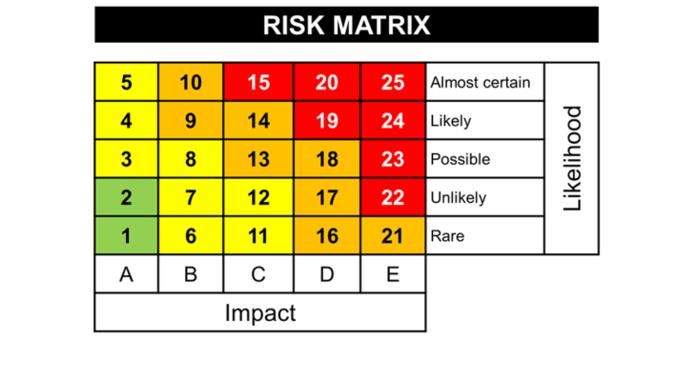

The O&M risk tolerance criteria that will be applied to risks mapped onto the risk matrix is specified here along with the O&M risk management response that will be applied.

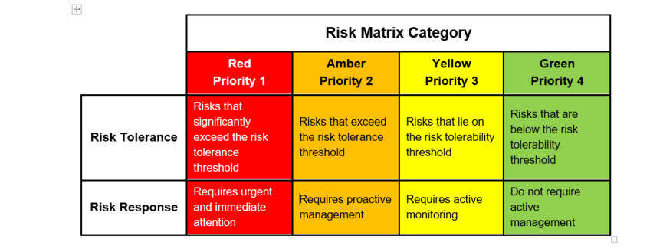

Attachments
- EOM-EM0-TP-000002 – O&M Risk Register Template

Attachment 1 - EOM-EM0-TP-000002 – O&M Risk Register Template
